The Power of Playing with Your Grandchildren
- Legacy Coalition Blog Team
- April 8, 2024
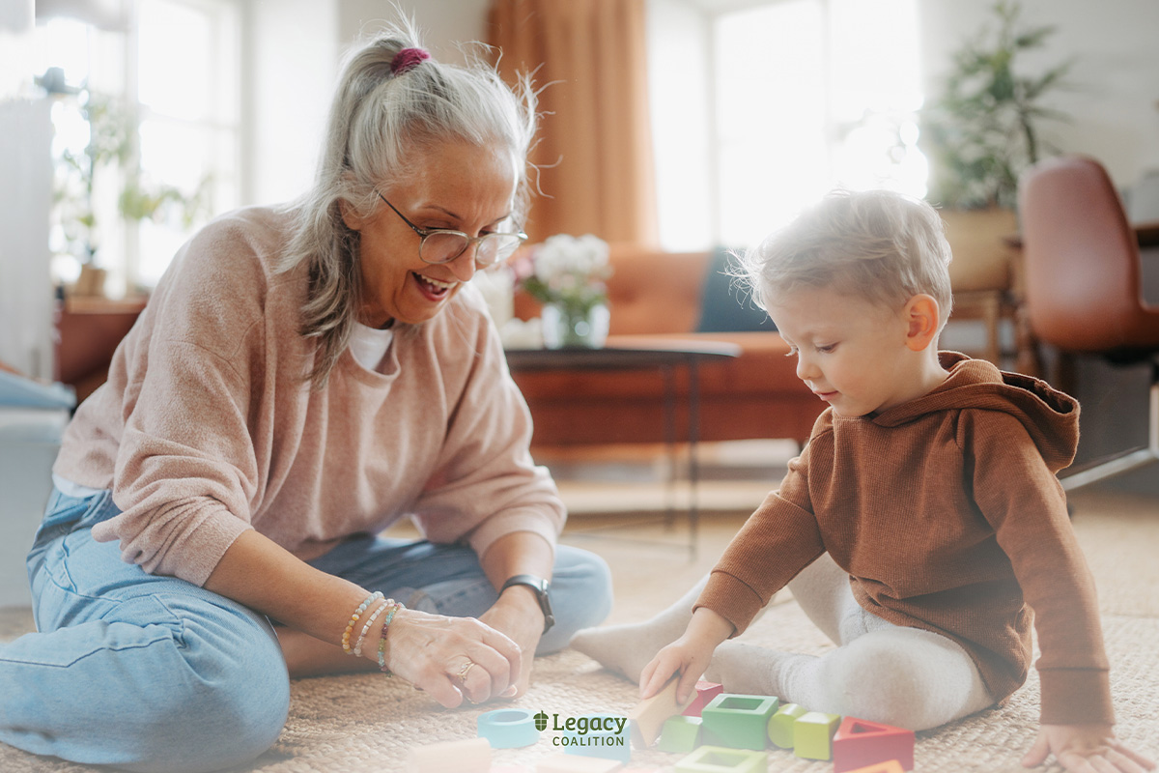
Written by Becky Danielson from Faith First Parent

“Grandma and Grandpa, do you want to play with me?”

It’s a common request grandparents hear from grandchildren. It’s an invitation to join in their world. From building with LegosTM on the bedroom floor to a game of pool, don’t miss out on your toddler to teen grandchild’s request to spend time together.
Playtime is a vital part of a child’s job description. Through play, children explore their world, growing socially, cognitively, and emotionally. This happens through both unstructured and structured playtime.
Organized sports, lessons, and activities are great, but family time is greater. Unstructured play, without adults acting as cruise directors, fuels creativity. Children come up with imaginative games and adventures.

The Benefits of Playtime
Social
Play offers kids an opportunity to practice communication skills, sharing, cooperating, resolving conflict, and building friendships. It’s a training ground for children to get along with others. Families build the primary foundation for relationships in children.
Cognitive
Play provides hands-on experiences, allowing children to experiment and try new activities. When a skill is mastered, it can be built upon for more difficult tasks or applied to other areas of learning. Children are multi-sensory learners, using all five senses to investigate and examine their world. Developmental psychologist Erik H. Erikson stated, “The playing adult steps sideward into another reality; the playing child advances forward to new stages of mastery.”
Emotional
While playing, children often act out emotions they are dealing with in life. This is a great time to help grandchildren put words to emotions as well as guide them in problem-solving. Step into your little one’s world with comments like, “I see you’re frustrated when the block tower you built tips over. Let’s see what happens if the base is bigger.” For tweens and teens, share your love for hiking, biking, and other recreational activities. Tell the grandkids about your past experiences as a kid. Share successes and failures from your own past to let them know you empathize and understand how they feel in various situations.
Spiritual
There’s a spiritual component to playtime too. Getting to know your grandchildren, having conversations, and sharing quality time together builds close relationships. Trusting relationships allow for honest conversations. Grandparents have a unique opportunity to speak Truth into their grandkids’ lives, ultimately leading them to Jesus. This is the best reason to play with your grandchildren.

Conclusion
Next time you’re asked, “Grandma and Grandpa, do you want to play with me?” say, “YES!” and join in the fun.
Remember the words of George Bernard Shaw, “We don’t stop playing because we grow old; we grow old because we stop playing.”

